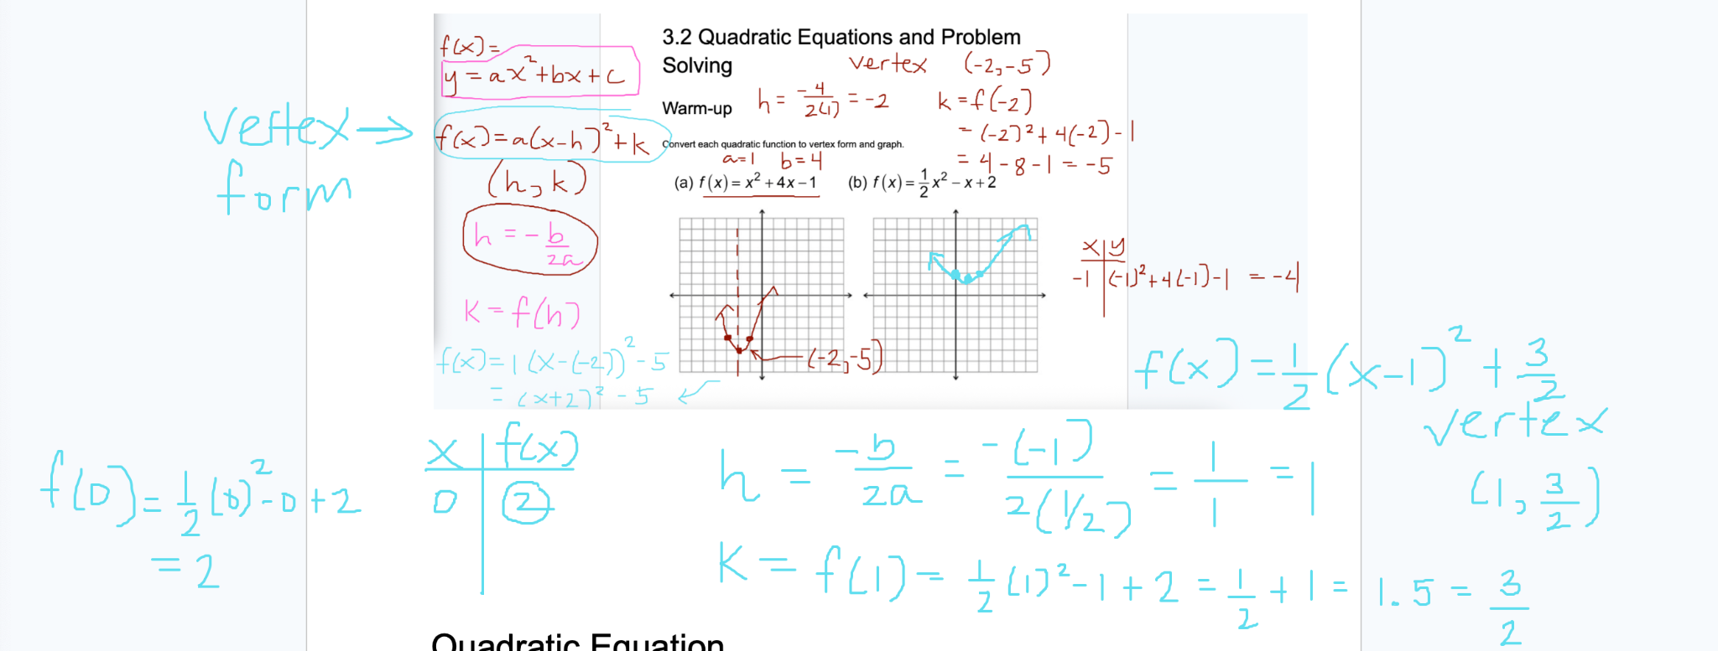

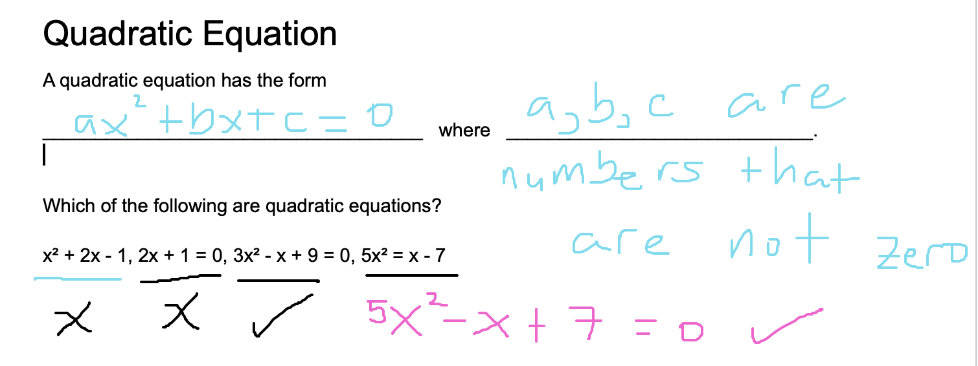

Number of solutions to a quadratic equation
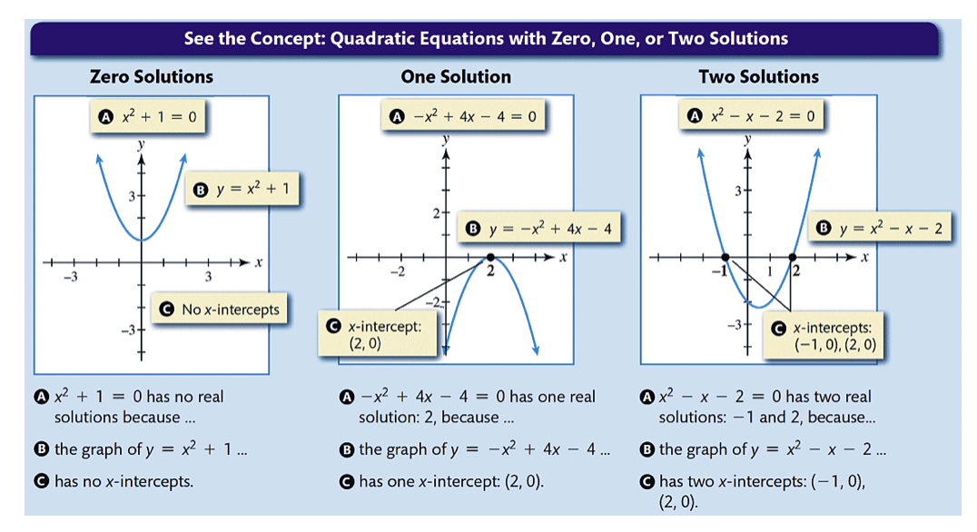

Solving quadratic equations
Four methods:
- Factoring
- Square root property
- Completing the square
- Quadratic formula

Factoring
The zero product property states that if I multiply two numbers and I get 0, then
one of the two numbers must be zero.

If AB = 0, then either A = 0 or B = 0.

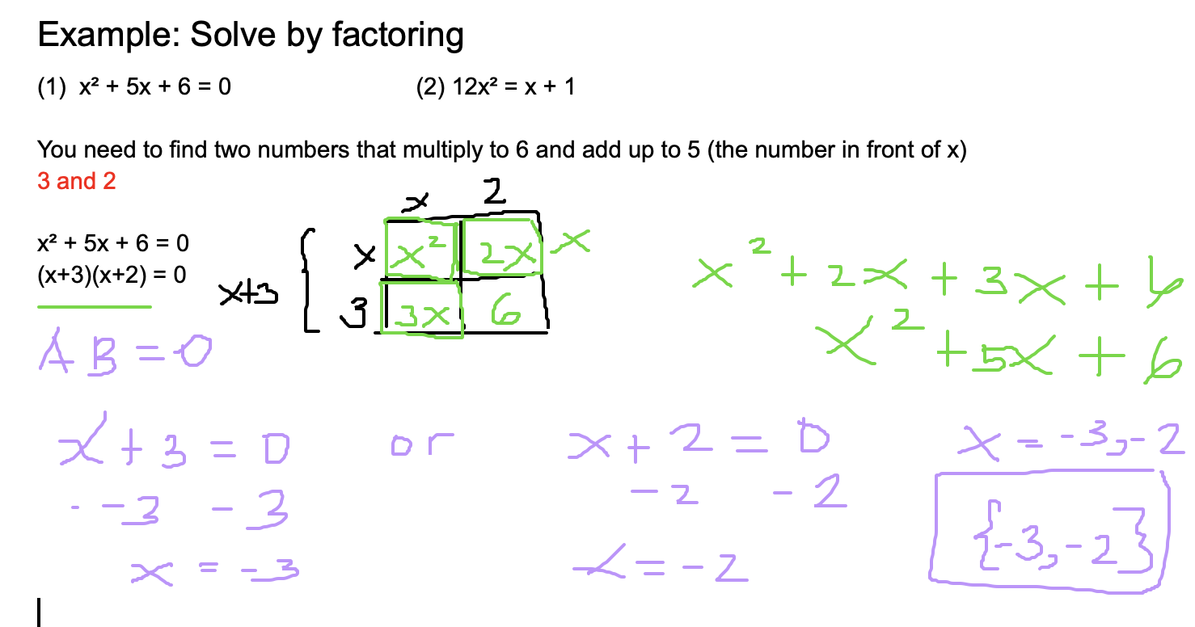

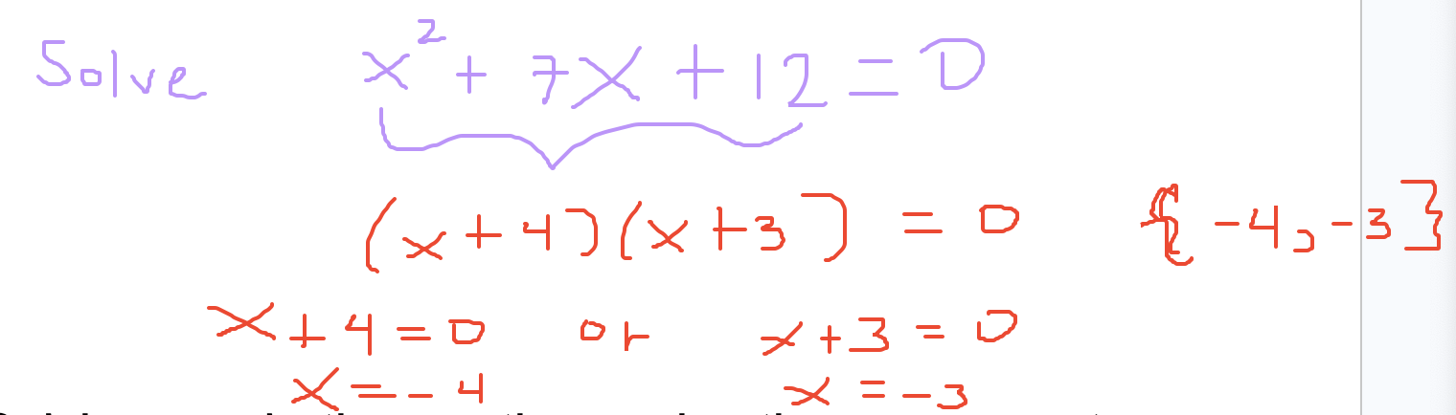

Solving quadratic equations using the square root property

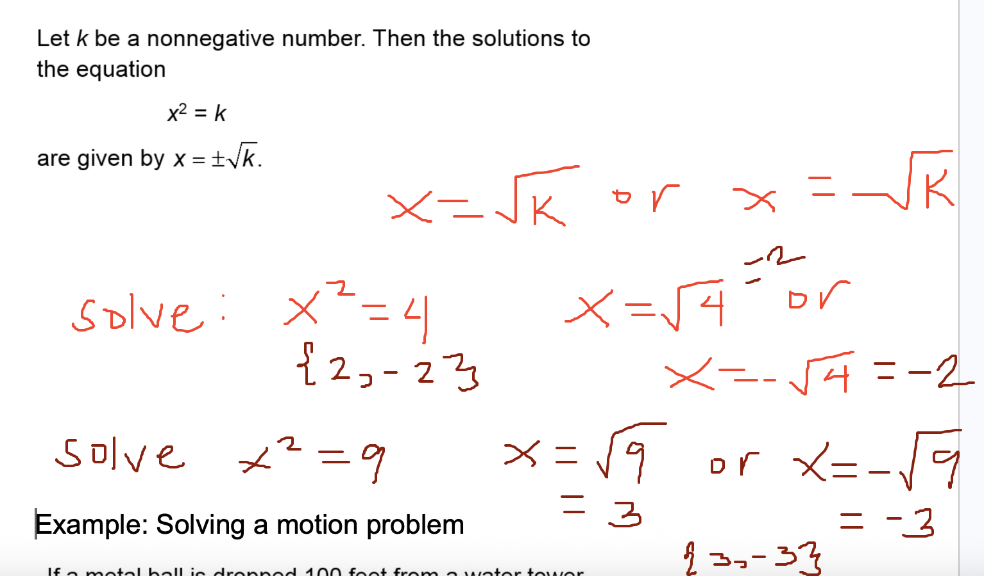

Example: Solving a motion problem
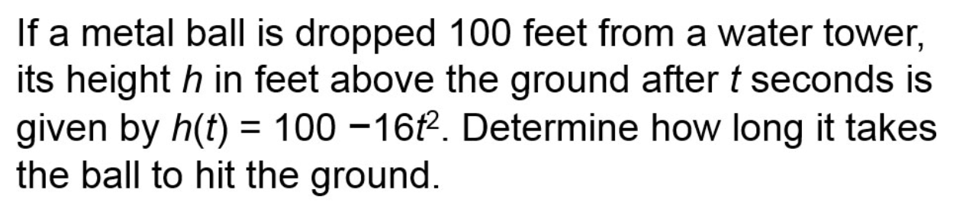

At ground level, what is h(t)? The value of h(t) is 0.
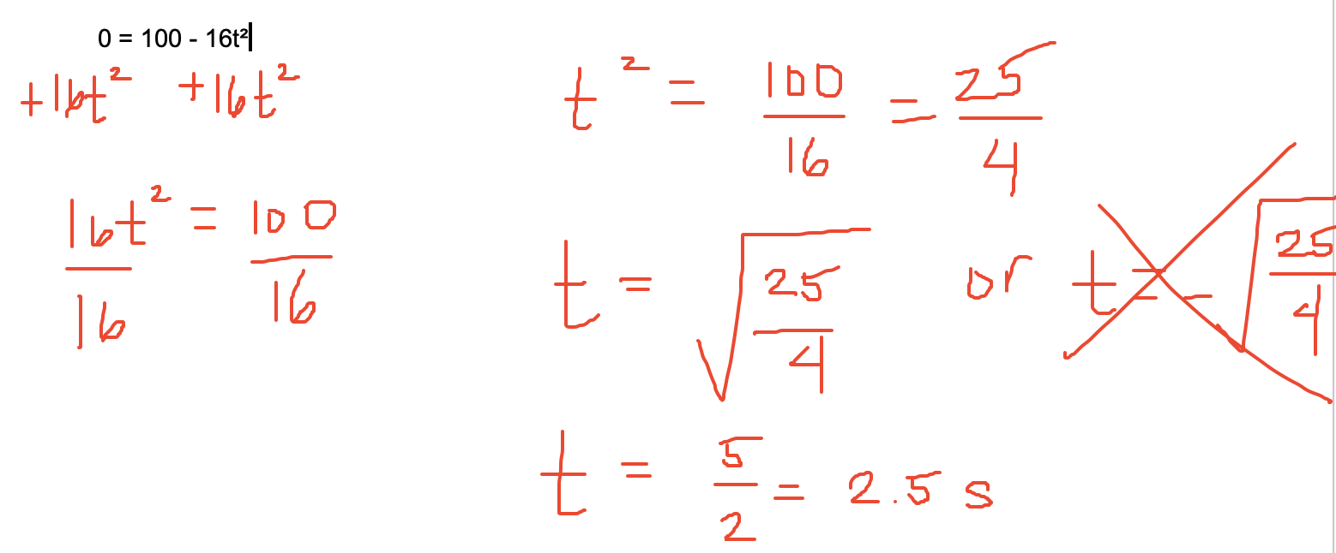

Solving quadratic equations by completing the square
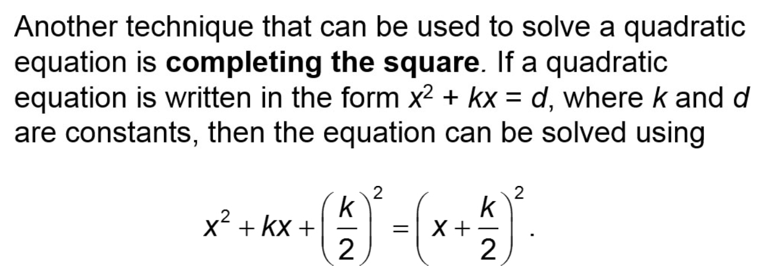

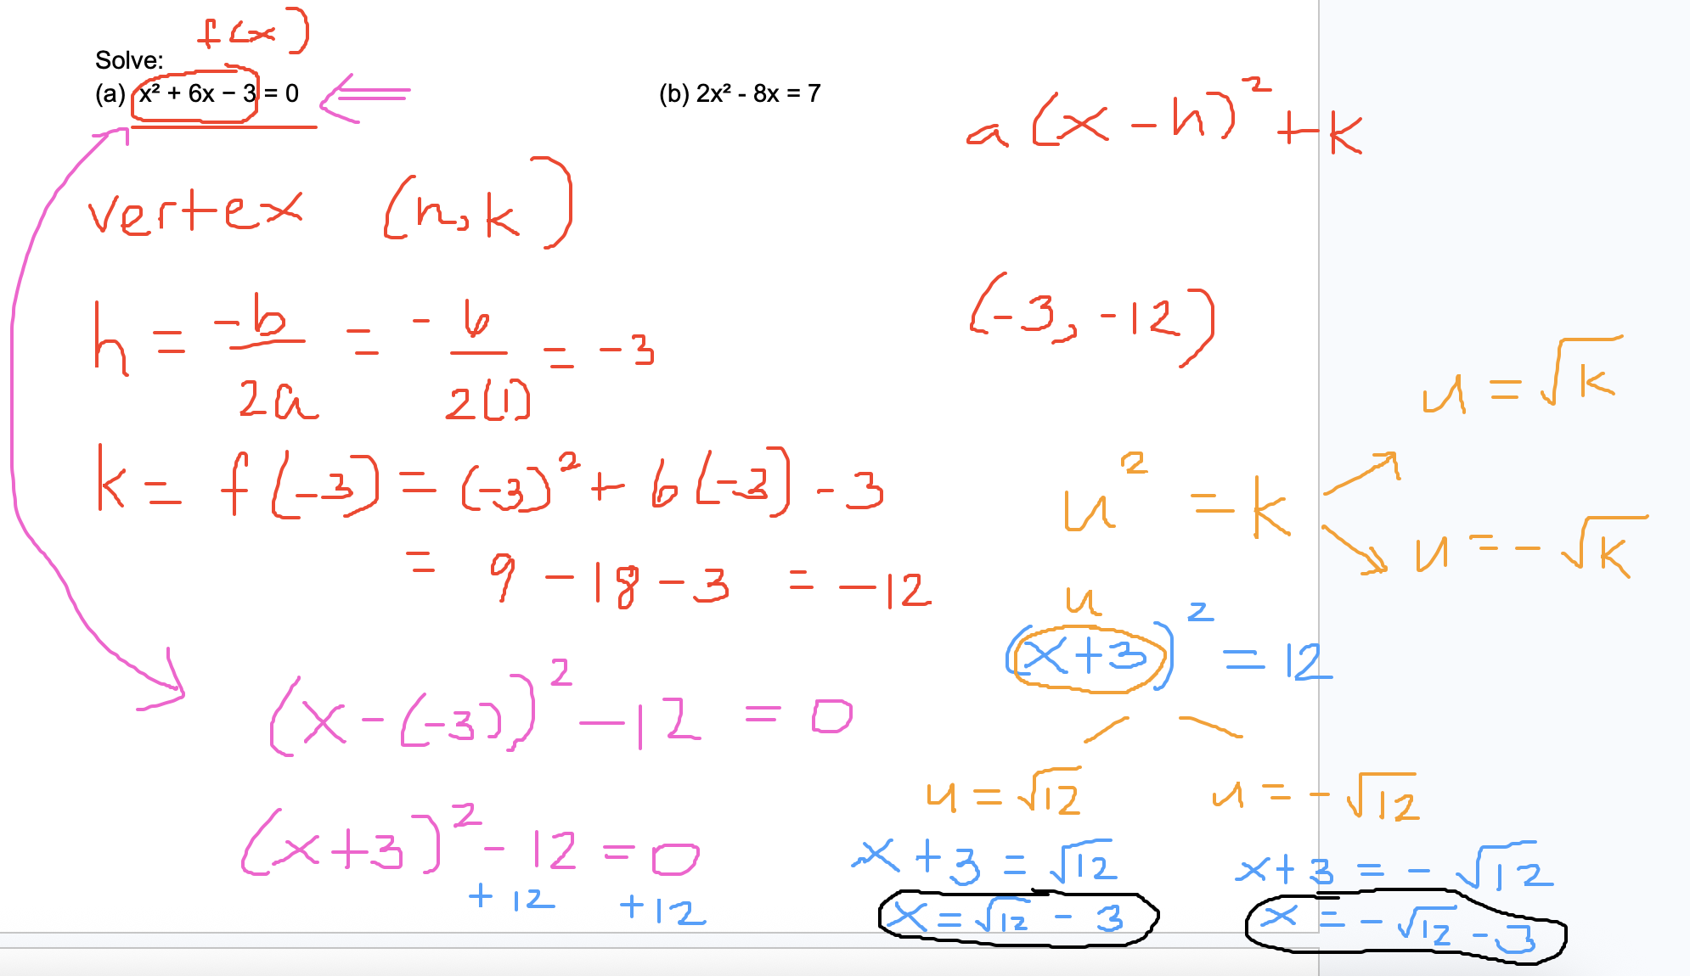

Solving quadratic equations by using the quadratic formula
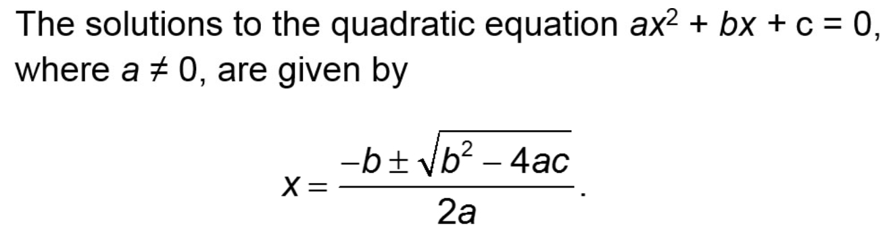

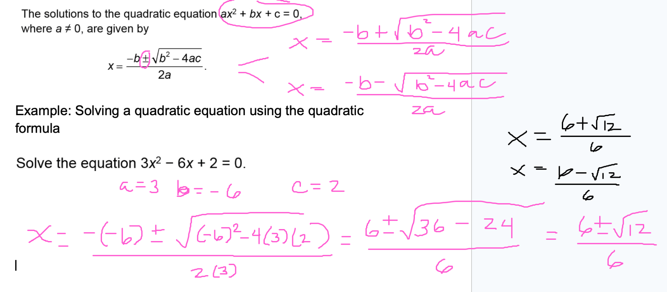

The discriminant is b²-4ac, which can be used to determine how many solutions a quadratic equation has. .

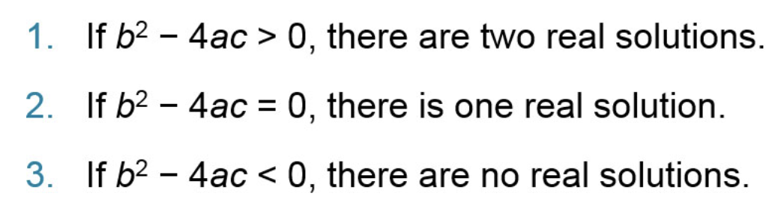
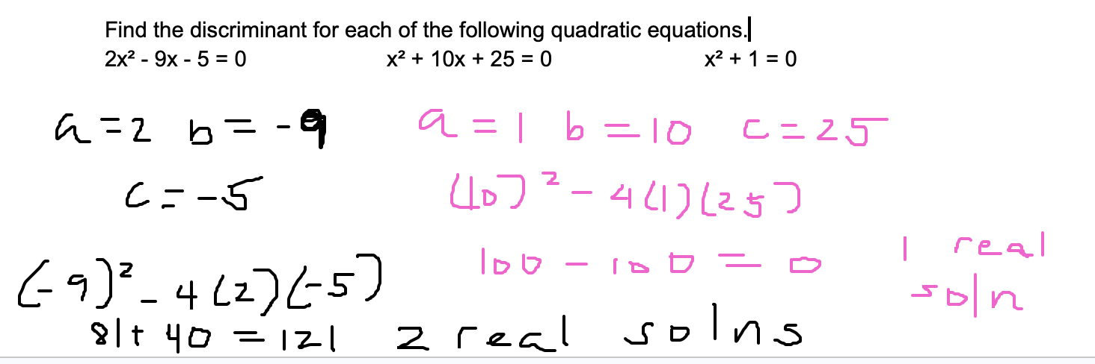

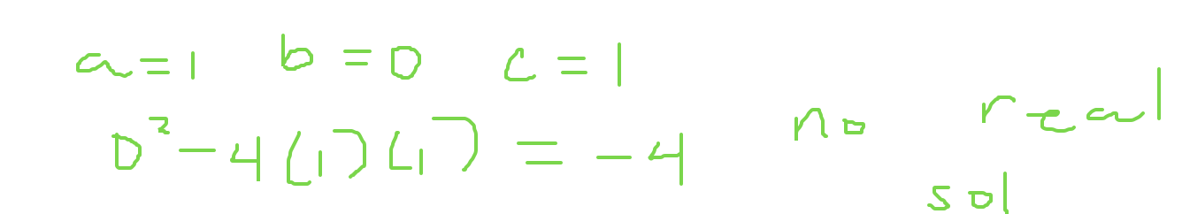

Example: Using the discriminant

